**INSIGHTSTREAM: NAVIGATE THE NEWS APP**

**1.INTRODUCTION**

* **Project title: News app**
* **Team members:**

1. **Nancy R (Team leader) Email id:(**[**nancy ranjithkumar2005@gmail.com**](mailto:nancyranjithkumar2005@gmail.com)**)**
2. **Priyadharshini D Email id:(** [**pd587022@gmail.com**](mailto:pd587022@gmail.com)**)**
3. **Raichel P R Email id:(**[**royjose1403@gmail.com**](mailto:royjose1403@gmail.com)**)**
4. **Raveena M Email id:(** [**m.raveena2004@gmail.com**](mailto:m.raveena2004@gmail.com)**)**



**2.PROJECT OVERVIEW**

**Purpose**

The primary goal of Insight Stream is to **simplify news consumption** by providing users with an **interactive and dynamic** platform where they can access the latest news across multiple categories. The application ensures **seamless navigation**, **efficient news discovery**, and **personalized content access**.

**Features**

* **Live News Updates** – Fetches news from APIs in real-time.
* **Categorized News** – Organized sections for Politics, Sports, Tech, etc.
* **Search Functionality** – Allows users to find specific news articles.
* **Trending Section** – Displays the most viewed and shared articles.
* **Newsletter Subscription** – Users can subscribe for daily updates.
* **User Authentication (Future Enhancement)** – Login system for personalized news feeds.



### **3.ARCHITECTURE**

### **Component Structure**

The application follows a **component-based architecture**, ensuring code reusability and maintainability.

#### Key Components

* **Navbar** – Contains search bar and category navigation.
* **Hero Section** – Highlights trending news.
* **Category Page** – Displays news articles based on selected categories.
* **Article Page** – Shows full article details and related articles.
* **Footer** – Contains links and subscription options.

### **State Management**

* **React Context API** – Manages global state (user preferences, selected categories).
* **use State & use Effect Hooks** – Handles dynamic updates and API calls.

### **Routing**

Implemented using **React Router** for navigation between pages.

* / – Home Page
* /category/:name – Category-wise news page
* /search/:query – Search results page
* /article/:id – Full article page



## **4. SETUP INSTRUCTIONS**

### **Prerequisites**

* Install **Node.js & npm**: [Download Here](https://nodejs.org/en/download/)
* Install **Git**: [Download Here](https://git-scm.com/downloads)
* Install **React.js**:

npm create-react-app news-app

* cd news-app

### **Installation**

1. **Clone the Repository**
2. git clone:
3. **N**:**Project Directory**
4. cd news-app-react
5. **Install Dependencies**
6. npm install
7. **Start the Development Server**
8. npm start
9. Open [**http://localhost:3000/**](http://localhost:3000/)in the browser.



## **5. FOLDER STRUCTURE**

### **Client**

### news-app/

* public/ – Static assets
* src/
  + components/ – Reusable UI components
  + pages/ – Page components
  + context/ – State management using Context API
  + styles/ – CSS & Styling files
  + App.js – Main application component
  + index.js – Entry point
* package.json – Dependencies
* README.md – Documentation

### **Utilities**

* Common helper functions for **API calls, data formatting, and state management**.



## **6. Running the Application**

### **Frontend**

1. Navigate to the project directory:
2. cd news-app
3. Install dependencies:
4. npm install
5. Start the React app:
6. npm start
7. Open http://localhost:3000/ in a browser.



## **7. Component Documentation**

### **Key Components**

* **Navbar** – Handles navigation and search.
* **Hero Section** – Displays trending news.
* **Category Page** – Shows news articles per category.
* **Article Page** – Displays the full news article.
* **Footer** – Contains additional links and social media.

### **Reusable Components**

* **News Card** – Reusable component for displaying news items.
* **Search Bar** – Allows users to search for news articles.



## **8.STATE MANAGEMENT**

### **Global State**

Managed using **React Context API**, ensuring consistent data across components.

### **Local State**

Handled using **use State** for managing user inputs, search queries, and filters.



**9.SCREENSHOT**

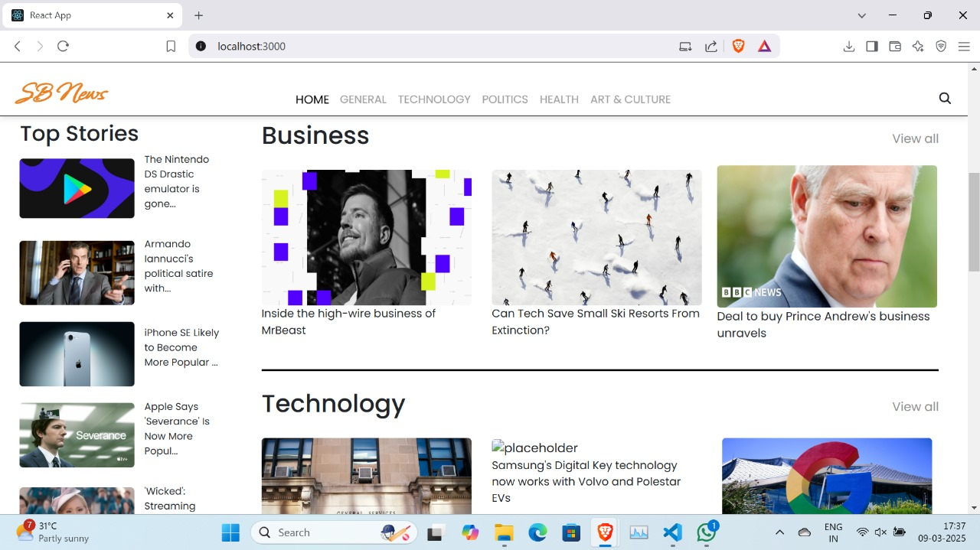

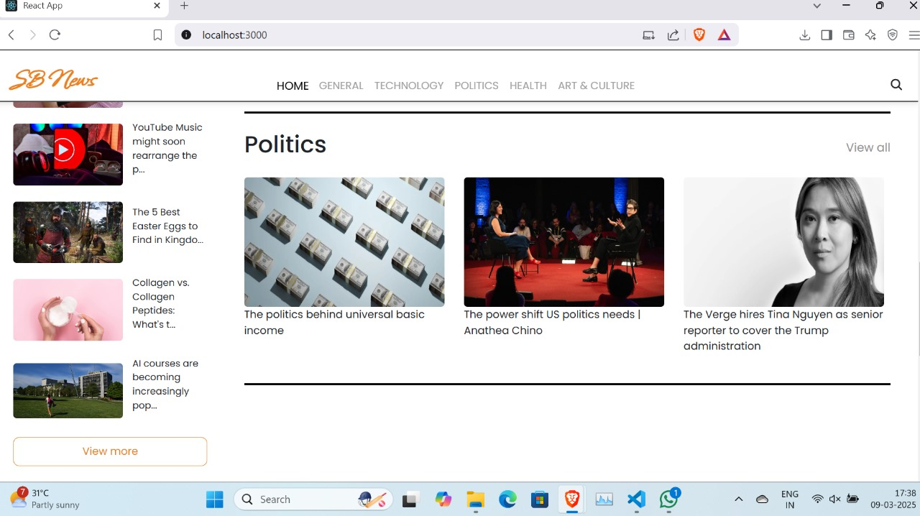

## **10.STYLING**

### **CSS Frameworks/Libraries**

* **Tailwind CSS / Bootstrap** for responsive design and faster styling.
* **Custom CSS Modules** for unique styling needs.

### **Theming**

* **Light & Dark Mode (Future Enhancement)** – User-selectable themes.



## **11. TESTING**

### **Testing Strategy**

* **Unit Testing** – Using Jest & React Testing Library.
* **Integration Testing** – API call validation with mock services.
* **UI Testing** – Checking responsiveness across devices.

### **Code Coverage**

* Ensure **80%+ test coverage** for components and functions.



## **12. KNOWN ISSUES**

* **API Rate Limit** – Free API key has request limitations.
* **No User Authentication** – Users cannot save favourite articles.
* **Limited Filtering** – Need better filtering for news searches.



## **13. FUTURE ENHANCEMENT**

### **Future Features**

* **User Authentication** – Allow users to create accounts and save news articles.
* **Dark Mode** – Provide an option for users to switch themes.
* **Push Notifications** – Notify users about breaking news.
* **AI-Based News Summarization** – Implement AI for article summaries.
* **Offline Mode** – Cache recent news for offline access.



## **Project Links**

* **Demo Link**: https://drive.google.com/file/d/1POEyfm7tzO3CC_Pcz_JQ3LZXpMMwXpRJ/view?usp=drivesdk



## **CONCLUSION**

Insight Stream is a **modern, scalable, and feature-rich** news app designed for **real-time news consumption**. While it currently provides **API-based news updates and category-based browsing**, future enhancements will focus on **user personalization, authentication, and AI-powered features** to improve the user experience.

